7.2.12 Editors - 3D View - Header - Particle - Particle mode - Particle menu
Particle Mode - Particle Menu 2
Mirror 2
Remove Doubles 2
Unify Length 2
Rekey 2
Weight Set 3
Last Operator Weight Set 3
Factor 3
Show/Hide 3
Show Hidden 3
Hide Selected 3
Hide Unselected 3
Brush Radius 3
Brush Strength 3

Particle Mode - Particle Menu
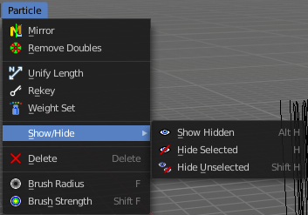

Mirror
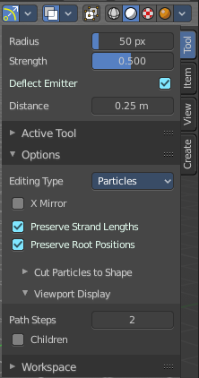
Mirrors the selected particles.
If you want a symmetrical haircut, first select all particles, then mirror the particles, then tick X Mirror in the Particle panel.

Remove Doubles
Remove double vertices that are very close to each other. This can for example happen when you mirror the particles.

Unify Length
Unifies the length of the selected hair particles. The length is calculated by the average length of the selection.

Rekey
You need to have some hair particles selected.
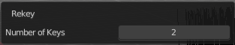
Rekey changes the number of keys for the selected particles, including root and tip keys. This tool brings up a popup where you can adjust the number of keys. Two means you have only a root and a tip key. Everything more subdivides the selected hair particle with more keys.

Weight Set
Here you can manually set a weight for the selected keys to interpolate between the current key weight and the brushes weight.

Last Operator Weight Set

Factor
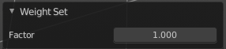
The strength of the keys weighting.

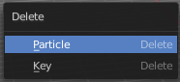
Delete
Delete either the whole particle, or just the selected key of the particle.

Show/Hide
Here you can show or hide the selected geometry

Show Hidden
Makes all hidden geometry visible again.

Hide Selected
Hides the selected geometry.

Hide Unselected
Hides the not selected geometry. The selected geometry stays visible.

Brush Radius
Adjust the brush radius.This is a hotkey tool, and should be performed in the viewport.

Brush Strength
Adjust the brush strength.This is a hotkey tool, and should be performed in the viewport.

